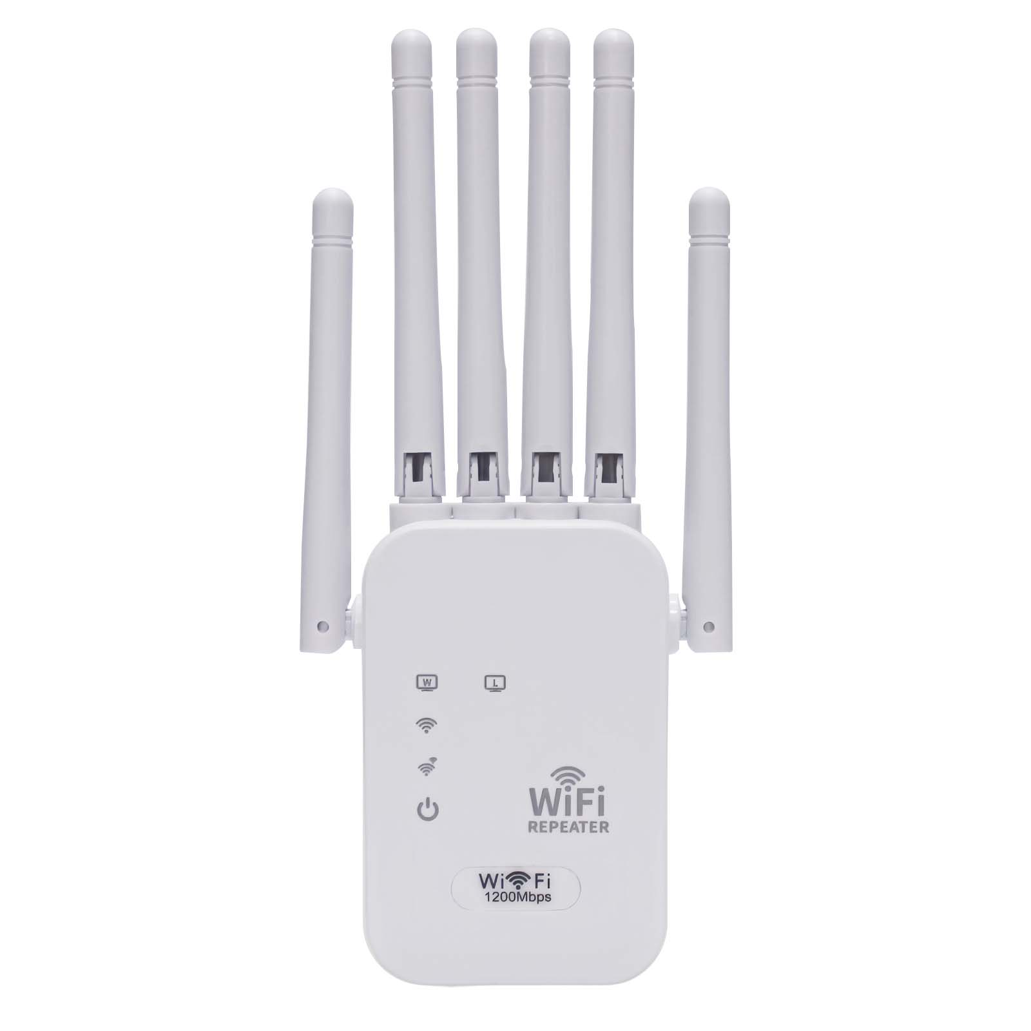
Product Characteristics
- Six external 3DB omnidirectional antennas;
- Support relay mode, AP mode;
- Built-in 100~240V 50/60Hz AC power module, no external power adapter;
- There are multiple specification standard plugs available for selection, supporting the Chinese standard, European standard, American standard, British standard, etc.
- 300Mbps transmission rate, 2.4GHz frequency band, wide coverage, wireless transmission more stable;
- The device is equipped with two 100M RJ45 ports. It supports the conversion from wireless to wired connection and can be connected to desktop computers, laptops, etc. for wired Internet access.
- Professional intelligent WiFi relay, support WiFi hotspot automatic scanning, and WiFi hotspot memory function;
- Support WEB background Chinese-English dual language interface, one-click setting wizard, quick and simple configuration;
- With good compatibility, compatible with all smart phones, tablets, laptops and other WiFi devices.
Product Specifications
Product Name |  | 300M Wireless Repeater
Product Model |  | Z300C
Hardware Specifications
Hardware System | Main chip |  | QCA9535
Hardware System | Memory |  | Buit-in 8MB
Hardware System | FLASH |  | 1MB
Wireless Parameters | Protocol standards |  | Support IEEE 802.11b/g/n
Wireless Parameters | Operating frequency band |  | 2.4GHz
Wireless Parameters | Wireless rate |  | 300Mbps
Wireless Parameters | Transmit power |  | 18dBm
Wireless Parameters | Antenna gain |  | 3dBi omnidirectional antenna *6
Wireless Parameters | Reception sensitivity |  | 90dBm ± 2dBm
Physical Interface | Network interface |  | 10/100Mbps LAN port *2
Physical Interface | Button |  | 1 reset key /WPS key
Indicator Light | LED indicator |  | PWR/WIFI/Repeater/LAN/LAN in that order
Power Supply/  Power Consumption | Mode of power supply |  | AC 100~240V 50/60Hz
Power Supply/  Power Consumption | Plug-type |  | Optional, support China, European, British, US and other specifications,etc
Power Supply/  Power Consumption | Power of the machine |  | < 5 w
Product Accessories | Device host |  | 300M dual band repeater host *1
Product Accessories | Other |  | User Manual *1, Certificate *1
Appearance/Packaging | Product dimensions |  | 180mm*84mm*34mm (L*W*H, does not include plug size)
Appearance/Packaging | Appearance color |  | White
Appearance/Packaging | Weight |  | 100g
Appearance/Packaging | Package size |  | 195*90*70mm（L*W*H）
Other | Covered area |  | 0 - 80㎡
Other | Use environment |  | Working temperature: -40℃ ~ 55℃  Storage temperature: -40℃ ~ 70℃  Working humidity: 10% ~ 90%RH non-condensing  Storage humidity: 5%-95%RH non-condensing
Software Specifications
Network | Work mode |  | Relay mode, AP mode
Wireless Security | Wireless security |  | Supports WPA2, WPA, WPA2-PSK AES, WEP encryption
Other | Product features |  | Professional intelligent WIFI repeater, support hotspot automatic scanning, support WIFI hotspot memory function
Other |  |  | The 2.4 GHz signal has a wider coverage area, and its transmission rate is faster and more stable.
Other | Number of user connections |  | Maximum number of user connections is 30
Other | System language |  | Chinese-english dual language adaptive
Other | Management mode |  | Web Configuration Management
Other | Applicable scenarios |  | Multi-home, duplex, cross-floor, rental house, apartment, villa, etc

Product size:
